RESUME

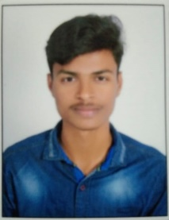
REDDY RAJULA SAI KIRAN

Phone : 9392844638

E-mail : saikiran1662003@gmail.com

To obtain a challenging position as a Software Engineer in a leading multi-national organization where I can use my qualifications and skills to prove my abilities.

S.NO. |  |  | 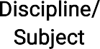 |  | 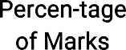
1. | B. Tech | ACE Engineering college,  Hyderabad | Electronics &Communicati--on Engg. | March 2025 (Pursuing) | 79  (Till date)
2. | Intermediate | Sri Chaitanya Jr.College, Hyderabad. | Maths, Physics, Chemistry. | March 2020 | 88
3. | S.S.C | Cardinal Gracious School,Ramantapur | Maths, Science, Social Studies | March  2019 | 92

TECHNICAL PROILE
- Operating Systems : Windows XP,VERSION 7 &11 and UBUNTU
- Languages : C,C++ & Python

PROJECT REPORT
  - Title : Blinking lights by using 555 timer IC
  - Duration : August to September (2023)
  - Purpose : Towards partial fulfillment for the award of my B.Tech,
Degree.
  - Material Used : Bread board , 555 Timer IC,LED etc.
  - Team Size : THREE (3)

ACHIEVEMENTS

    - Cisco C Certificate
    - Cisco Python Certificate
    - SVIP Certificate

STRENGTHS

- Positive Attitude
- Self motivated

WEAKNESSES

- Have a difficulty in saying NO

HOBBIES

- Listening to music
- Watching movies

PERSONAL PROFILE

Date of Birth : 16st June 2003

Languages known : Telugu ,Hindi, English

Father’s Name : Mr. R Srinu

Mother’s Name : Mrs. R Padma

Address : H.NO: 3-10-66 Ghokale nagar,Ramanthapur, Hyderabad-500013

DECLARATION

It is hereby acknowledged that the information furnished above is true to my knowledge

Place : Hyderabad

Date : 07-02-2024

signature

* * *

